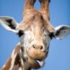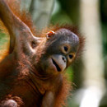Animals of the World

Choose an Animal

Discover:

**Cool Facts -**

**Habitat (Location where they live) -**

**Characteristics -**

**Hibernate? Nocturnal? -**

**Footprints -**

**Diet (What they eat) -**

**Endangered? -**

**How Can We Help? -**

**Questions? -**

**Save Lots of Pictures!**

**Create A PowerPoint Slide Show!**